Objective Questions

1- List the different dtypes of columns in table “ball_by_ball” (using information schema).

Code - select column_name, data_type from information_schema.columns
where table_schema = 'ipl'
and table_name = 'ball_by_ball';
Output image of SQL - 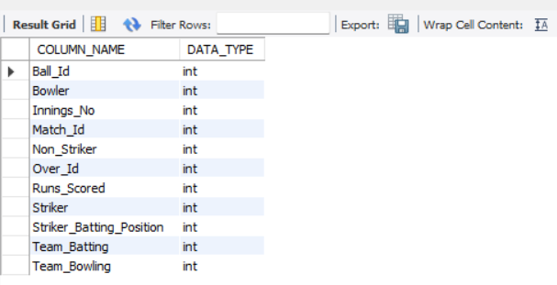
Visualization (Wherever required) - NA
Brief answer explanation -
This query retrieves the column names and their corresponding data types from the ball_by_ball table using MySQL's INFORMATION_SCHEMA.COLUMNS. The TABLE_SCHEMA filter ensures that the query searches only within the ipl database, while TABLE_NAME specifies the required table. This is useful for understanding the table structure without accessing the actual data.

2- What is the total number of runs scored in 1st season by RCB (bonus: also include the extra runs using the extra runs table).

Code - SELECT
(SELECT SUM(Runs_Scored)
FROM ball_by_ball
WHERE Team_Batting = 2
AND Match_Id IN (
SELECT Match_Id FROM matches
WHERE Season_Id = 6 AND (Team_1 = 2 OR Team_2 = 2)
)) AS Total_Runs,

(SELECT SUM(e.Extra_Runs)
FROM extra_runs e
JOIN ball_by_ball b
ON e.Match_Id = b.Match_Id AND e.Over_Id = b.Over_Id
AND e.Ball_Id = b.Ball_Id AND e.Innings_No = b.Innings_No
WHERE b.Team_Batting = 2
AND e.Match_Id IN (
SELECT Match_Id FROM matches
WHERE Season_Id = 6 AND (Team_1 = 2 OR Team_2 = 2)
)) AS Total_Extras,

(SELECT SUM(Runs_Scored)
FROM ball_by_ball
WHERE Team_Batting = 2
AND Match_Id IN (
SELECT Match_Id FROM matches
WHERE Season_Id = 6 AND (Team_1 = 2 OR Team_2 = 2)
))
+
(SELECT SUM(e.Extra_Runs)
FROM extra_runs e
JOIN ball_by_ball b
ON e.Match_Id = b.Match_Id AND e.Over_Id = b.Over_Id
AND e.Ball_Id = b.Ball_Id AND e.Innings_No = b.Innings_No
WHERE b.Team_Batting = 2
AND e.Match_Id IN (
SELECT Match_Id FROM matches
WHERE Season_Id = 6 AND (Team_1 = 2 OR Team_2 = 2)
)) AS Total_Including_Extras;

Output image of SQL -
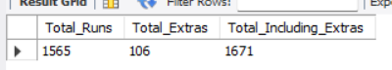

Visualization (Wherever required) – NA

Brief answer explanation -
RCB's first season in the dataset is Season_Id = 6 (2013). Match IDs for RCB (Team_Id = 2) were identified from the matches table where RCB appears as Team_1 or Team_2. Runs scored were summed from ball_by_ball where Team_Batting = 2, giving 1565 runs. Extras were pulled from extra_runs, joined to ball_by_ball on Match_Id, Over_Id, Ball_Id, and Innings_No to isolate RCB's batting innings, adding 106 extra runs. Total including extras: 1671 runs..

3 - How many players were more than the age of 25 during season 2014?
Code - select count(distinct p.Player_Id) AS Total_Players
from Player p
join Player_Match pm
on p.Player_Id = pm.Player_Id
join Matches m
on pm.Match_Id = m.Match_Id
where m.Season_Id = 7
and timestampdiff(year, p.DOB, '2014-04-01') > 25;

Output image of SQL -
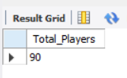

Visualization (Wherever required) – NA

Brief answer explanation - The query joins the Player, Player_Match, and Matches tables to identify players who participated in the 2014 IPL season. It calculates each player's age using TIMESTAMPDIFF() and counts only unique players who were older than 25 years.

4 - How many matches did RCB win in 2013?
Code - select count(*) as matches_won
from matches
where season_id = 6 and
match_winner = 2;
Output image of SQL -
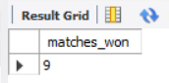
Visualization (Wherever required) – NA

Brief answer explanation - The query counts the number of matches won by RCB in the 2013 IPL season. It filters the Matches table for Season_Id = 6 (2013) and Match_Winner = 2 (RCB), then returns the total number of matching records
5- List the top 10 players according to their strike rate in the last 4 seasons.
Code -
select
p.player_name,
sum(b.runs_scored) as total_runs,
count(*) as balls_faced,
round((sum(b.runs_scored) * 100.0) / count(*), 2) as strike_rate
from ball_by_ball b
join matches m
on b.match_id = m.match_id
join player p
on b.striker = p.player_id
where m.season_id in (6, 7, 8, 9)
group by p.player_id, p.player_name
order by strike_rate desc
limit 10;
Output image of SQL -
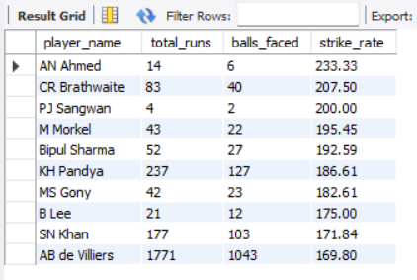
Visualization (Wherever required) – NA
Brief answer explanation -
This query calculates the strike rate of each player in the last four seasons (Season IDs 6, 7, 8, and 9). It joins the ball_by_ball, matches, and player tables to retrieve the runs scored, filter the required seasons, and display player names. The strike rate is calculated using the formula:
Strike Rate = (Total Runs × 100) / Balls Faced
The results are sorted in descending order of strike rate, and the top 10 players are displayed.
6- What are the average runs scored by each batsman considering all the seasons?
Code -
select p.player_name,
round(avg(t.match_runs), 2) as average_runs
from (select match_id, striker,
sum(runs_scored) as match_runs
from ball_by_ball
group by match_id, striker) as t
join player p
on t.striker = p.player_id
group by p.player_id, p.player_name
order by average_runs desc;
Output image of SQL -
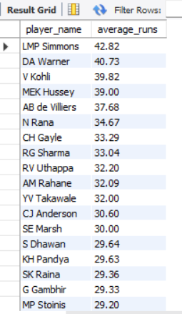
Visualization (Wherever required) – NA
Brief answer explanation -
This query calculates the average runs scored per match by each batsman across all seasons. First, the subquery calculates the total runs scored by each batsman in every match. Then, the outer query joins the player table to display player names and calculates the average of those match totals using the AVG() function. Finally, the results are sorted in descending order of average runs.
8- What are the average wickets taken by each bowler considering all the seasons?
Code -
select p.player_name,
round(avg(t.match_wickets), 2) as average_wickets
from (select b.match_id, b.bowler,
count(*) as match_wickets
from wicket_taken as w
join ball_by_ball as b
on w.match_id = b.match_id
and w.over_id = b.over_id
and w.ball_id = b.ball_id
and w.innings_no = b.innings_no
group by b.match_id, b.bowler) as t
join player as p on t.bowler = p.player_id
group by p.player_id, p.player_name
order by average_wickets desc;
Output image of SQL -
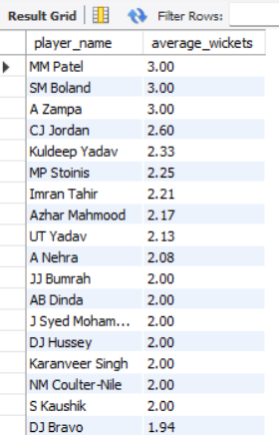
Visualization (Wherever required) – NA
Brief answer explanation -
This query calculates the average wickets taken per match by each bowler across all seasons. The wicket_taken table is joined with the ball_by_ball table to identify the bowler for each wicket. The subquery counts the total wickets taken by each bowler in every match. The outer query then calculates the average of these match-wise wicket totals using the AVG() function and displays the results in descending order.
8 - List all the players who have average runs scored greater than the overall average and who have taken wickets greater than the overall average.
Code -
with batting as(select striker,
avg(match_runs) as avg_runs
from
(select match_id, striker,
sum(runs_scored) as match_runs
from ball_by_ball
group by match_id, striker
) as t group by striker),
bowling as (select bowler,
avg(match_wickets) as avg_wickets
from
(select b.match_id, b.bowler,
count(*) as match_wickets
from wicket_taken as w
join ball_by_ball as b
on w.match_id = b.match_id
and w.over_id = b.over_id
and w.ball_id = b.ball_id
and w.innings_no = b.innings_no
group by b.match_id, b.bowler)
as t group by bowler)
select p.player_name,
bt.avg_runs, bw.avg_wickets
from batting as bt
join bowling as bw
on bt.striker = bw.bowler
join player as p
on bt.striker = p.player_id
where bt.avg_runs > (select avg(avg_runs) from batting)
and bw.avg_wickets > (select avg(avg_wickets) from bowling)
order by bt.avg_runs desc, bw.avg_wickets desc;
Output image of SQL -
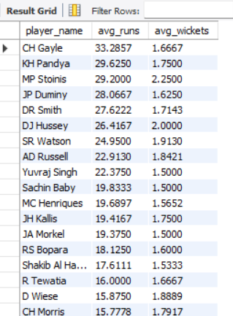
Visualization (Wherever required) – NA
Brief answer explanation -
This query identifies players who perform better than average in both batting and bowling. Two CTEs are created: the first calculates each player's average runs per match, and the second calculates each player's average wickets per match. These averages are then compared with the overall batting and bowling averages. Finally, only players whose average runs and average wickets are both above the overall averages are displayed.
9- Create a table rcb_record table that shows the wins and losses of RCB in an individual venue.
Code-
create table rcb_record as
select v.venue_name,
count(case when m.match_winner = 2 then 1 end) as wins,
count(case
when (m.team_1 = 2 or m.team_2 = 2)
and m.match_winner <> 2
and m.match_winner is not null
then 1 end) as losses
from matches as m
join venue as v
on m.venue_id = v.venue_id
where m.team_1 = 2
or m.team_2 = 2
group by v.venue_name;
Output image of SQL -
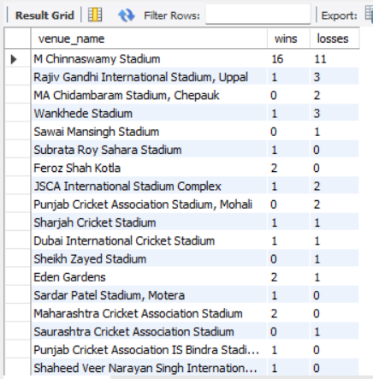
Visualization (Wherever required) – NA
Brief answer explanation -
This query creates a new table named rcb_record that stores RCB's performance at each venue. It filters only the matches where RCB participated, groups the matches by venue, counts the matches won by RCB, and counts the matches lost by RCB. The resulting table provides the number of wins and losses for RCB at every venue.
10- What is the impact of bowling style on wickets taken?
Code -
select bs.bowling_skill,
count(*) as total_wickets
from wicket_taken as w
join ball_by_ball as b
on w.match_id = b.match_id
and w.over_id = b.over_id
and w.ball_id = b.ball_id
and w.innings_no = b.innings_no
join player as p
on b.bowler = p.player_id
join bowling_style as bs
on p.bowling_skill = bs.bowling_id
group by bs.bowling_skill
order by total_wickets desc;
Output image of SQL -
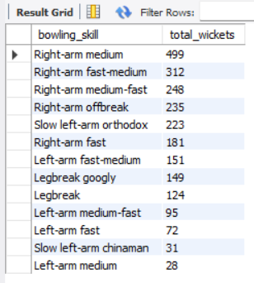
Visualization (Wherever required) –
Brief answer explanation -
This query analyzes the impact of different bowling styles by counting the total wickets taken by bowlers of each style. It joins the wicket_taken, ball_by_ball, player, and bowling_style tables to identify the bowler and their bowling style. The results are grouped by bowling style and sorted in descending order of total wickets.
From the visualization, right-arm medium bowlers have taken the highest number of wickets, followed by right-arm fast-medium and right-arm medium-fast bowlers. This indicates that these bowling styles have been the most effective in taking wickets in the dataset.
11 - Write the SQL query to provide a status of whether the performance of the team is better than the previous year's performance on the basis of the number of runs scored by the team in the season and the number of wickets taken.
Code -
with season_runs as
(select m.season_id,
sum(b.runs_scored) as total_runs
from matches as m
join ball_by_ball as b
on m.match_id = b.match_id
where b.team_batting = 2
group by m.season_id),
season_wickets as
(select m.season_id,
count(*) as total_wickets
from wicket_taken as w
join ball_by_ball as b
on w.match_id = b.match_id
and w.over_id = b.over_id
and w.ball_id = b.ball_id
and w.innings_no = b.innings_no
join matches as m
on b.match_id = m.match_id
where b.team_bowling = 2
group by m.season_id)
select
r.season_id, r.total_runs, w.total_wickets, case
when r.total_runs > lag(r.total_runs) over(order by r.season_id)
and w.total_wickets > lag(w.total_wickets) over(order by r.season_id)
then 'Better' else 'Not Better'
end as performance_status
from season_runs as r
join season_wickets as w
on r.season_id = w.season_id
order by r.season_id;
Output image of SQL -
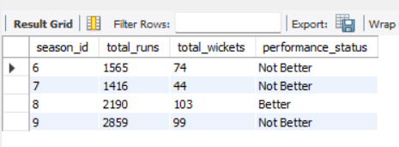
Visualization (Wherever required) –
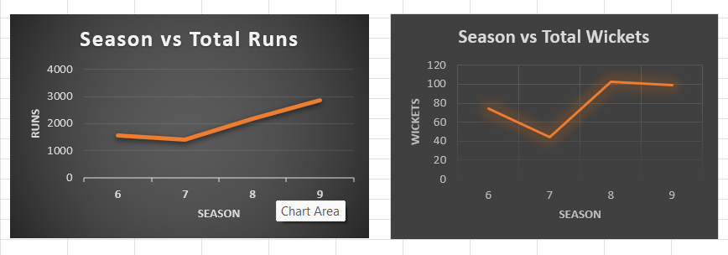
These line charts illustrate RCB's performance trend across seasons by showing the total runs scored and total wickets taken. They make it easy to compare the team's performance with the previous season.

Brief answer explanation -
This query analyzes RCB's season-wise performance using two key metrics: total runs scored and total wickets taken. Two CTEs are created to calculate these metrics for each season. The LAG() window function is then used to compare the current season's performance with the previous season. If both the total runs and total wickets are higher than the previous season, the performance status is marked as 'Better'; otherwise, it is marked as 'Not Better'.
12 - Can you derive more KPIs for the team strategy?
Code - NA
Output image of SQL - NA
Visualization (Wherever required) – NA

Brief answer explanation -
Apart from the KPIs analyzed in this project, the following additional KPIs can provide deeper insights into RCB's performance and help improve the team's strategy:
KPI | Purpose
Win Percentage | Measures the team's overall success rate across seasons.
Home vs Away Performance | Compares the team's performance at home and away venues.
Powerplay Performance | Evaluates runs scored and wickets lost in the first six overs.
Death Overs Performance | Measures batting and bowling effectiveness during the last five overs.
Boundary Percentage | Calculates the percentage of runs scored through fours and sixes.
Dot Ball Percentage | Measures bowling pressure by calculating the percentage of dot balls.
Bowling Economy Rate | Identifies bowlers who concede the fewest runs per over.
Batting Partnership Analysis | Identifies the most successful batting partnerships.
Venue-wise Performance | Determines the venues where RCB performs best and worst.
Opposition-wise Performance | Analyzes RCB's performance against different teams.
Player Consistency Index | Measures players' consistency across multiple seasons.
Fielding Efficiency | Evaluates fielding performance through catches, run-outs, and stumpings.
These KPIs provide valuable insights into batting, bowling, fielding, venue performance, and player consistency. They help the team management make informed decisions regarding team selection, match planning, player roles, and overall performance improvement.

13 - Using SQL, write a query to find out the average wickets taken by each bowler in each venue. Also, rank the gender according to the average value.
Code -
with bowler_match_wickets as
(select m.venue_id, b.match_id,
b.bowler, count(*) as wickets
from wicket_taken as w
join ball_by_ball as b
on w.match_id = b.match_id
and w.over_id = b.over_id
and w.ball_id = b.ball_id
and w.innings_no = b.innings_no
join matches as m
on b.match_id = m.match_id
group by m.venue_id, b.match_id,
b.bowler)
select v.venue_name, p.player_name,
round(avg(bmw.wickets),2) as average_wickets,
dense_rank() over(partition by v.venue_name
order by avg(bmw.wickets) desc
) as bowler_rank
from bowler_match_wickets as bmw
join player p on bmw.bowler = p.player_id
join venue as v
on bmw.venue_id = v.venue_id
group by v.venue_name, p.player_name
order by v.venue_name, bowler_rank;
Output image of SQL -
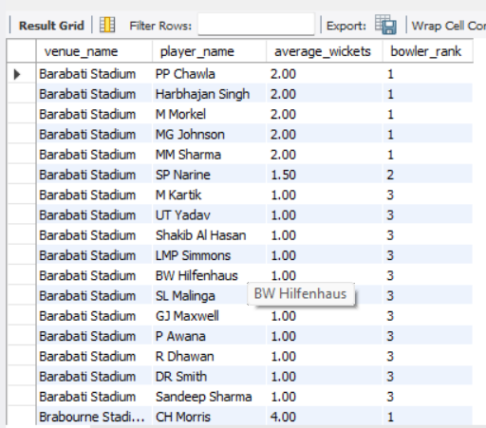
Visualization (Wherever required) –
Description:
The horizontal bar chart displays the average wickets taken by bowlers at Barabati Stadium. The bowlers are arranged based on their average wickets, making it easy to identify the best-performing bowlers at this venue. Similar charts can be created for other venues using the same analysis.

Brief answer explanation -
This query calculates the average wickets taken by each bowler at every venue. A Common Table Expression (CTE) is first used to calculate the number of wickets taken by each bowler in every match played at a venue. The outer query then computes the average wickets for each bowler across all matches at that venue. Finally, the DENSE_RANK() window function ranks the bowlers within each venue based on their average wickets, where the highest average receives Rank 1.
This analysis helps identify the most effective bowlers at different venues, enabling teams to make informed decisions regarding player selection and bowling strategies.
14 - Which of the given players have consistently performed well in past seasons? (will you use any visualization to solve the problem).
Code -
with season_runs as
(select m.season_id, b.striker,
sum(b.runs_scored) as total_runs
from ball_by_ball as b
join matches as m
on b.match_id = m.match_id
group by m.season_id, b.striker)
select p.player_name,
count(sr.season_id) as seasons_played,
round(avg(sr.total_runs),2) as average_runs,
dense_rank() over(order by avg(sr.total_runs) desc) as player_rank
from season_runs as sr
join player as p
on sr.striker = p.player_id
group by
p.player_id, p.player_name
having count(sr.season_id) > 1
order by player_rank
limit 10;
Output image of SQL -
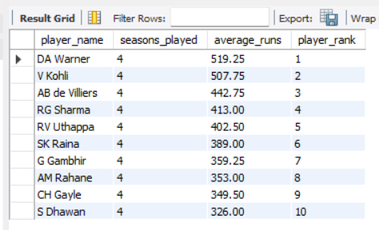
Visualization (Wherever required) –
Description:
The horizontal bar chart displays the Top 10 players based on their average runs scored across multiple IPL seasons. Players with higher average runs are considered more consistent performers. The visualization clearly highlights the most reliable batsmen, making it easy to compare their long-term performance.
Brief answer explanation -
This query identifies the most consistent players by calculating the total runs scored by each player in every season and then computing their average runs across all seasons played. Players who have participated in more than one season are considered for the analysis. The DENSE_RANK() window function ranks players based on their average runs, where the player with the highest average receives Rank 1. This approach provides a reliable measure of batting consistency over multiple IPL seasons.
15 - Are there players whose performance is more suited to specific venues or conditions? (how would you present this using charts?)
Code -
with venue_runs as
(select v.venue_name, b.striker,
sum(b.runs_scored) as total_runs
from ball_by_ball as b
join matches as m
on b.match_id = m.match_id
join venue as v
on m.venue_id = v.venue_id
group by v.venue_name, b.striker),
ranked_players as (select
vr.venue_name, p.player_name, vr.total_runs,
dense_rank() over
(partition by vr.venue_name
order by vr.total_runs desc) as player_rank
from venue_runs as vr
join player as p
on vr.striker = p.player_id)
select * from ranked_players
where player_rank <= 10
order by venue_name, player_rank;
Output image of SQL –
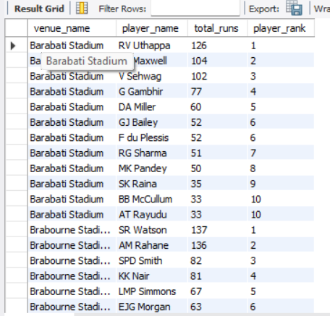
Visualization (Wherever required) –
Description -
The SQL query identifies the Top 10 players for every venue based on the total runs scored. Since the dataset contains multiple venues and numerous player–venue combinations, displaying all results in a single chart would make the visualization cluttered and difficult to interpret. Therefore, a sample visualization for M. Chinnaswamy Stadium is presented using a Horizontal Clustered Bar Chart.
This chart clearly compares the top-performing players at the selected venue. The same analysis can be performed for any other venue by applying the Venue Filter in Excel or Power BI, making the visualization interactive and easy to understand.

Brief answer explanation -
This query calculates the total runs scored by each player at every venue and ranks them using the DENSE_RANK() window function. The ranking is performed separately for each venue, allowing the identification of the top-performing players at individual stadiums. The analysis helps determine whether certain players consistently perform better under specific venue conditions and identifies venue specialists.

Subjective Questions
1 - How does the toss decision affect the result of the match? (which visualizations could be used to present your answer better) And is the impact limited to only specific venues?
Code -
select v.venue_name,
case
when m.toss_decide = 1 then 'field first'
when m.toss_decide = 2 then 'bat first'
end as toss_decision,
count(*) as total_matches,
sum(case
when m.match_winner = 2 then 1
else 0 end) as matches_won,
count(*) -
sum(case when m.match_winner = 2 then 1
else 0 end) as matches_lost,
round(sum(case
when m.match_winner = 2 then 1 else 0
end) * 100.0 / count(*),
2) as win_percentage
from matches as m
join venue as v
on m.venue_id = v.venue_id
where m.toss_winner = 2
group by
v.venue_name, m.toss_decide
order by
v.venue_name, win_percentage desc;
Output image of SQL -
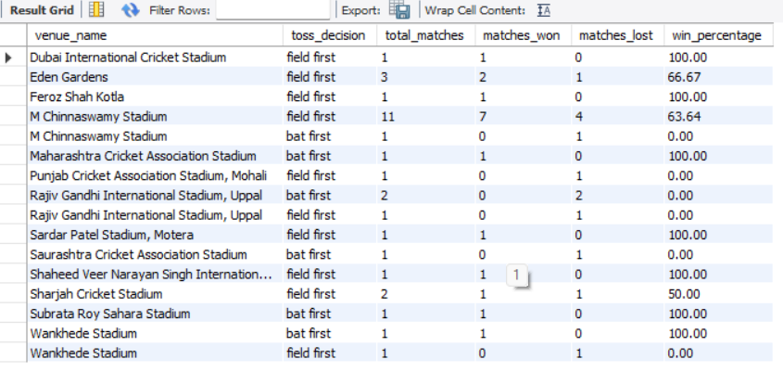
Visualization (Wherever required) –
Approach-
The analysis focuses on RCB's toss decisions by considering the matches where RCB won the toss. The data is grouped by venue and toss decision (Bat First / Field First) to calculate the total matches, matches won, matches lost, and win percentage. A clustered column chart is used to compare the success rate of both toss decisions across different venues.
Insight -
- RCB has achieved a 63.64% win percentage after choosing to field first at M. Chinnaswamy Stadium, suggesting that chasing has been a more successful strategy at their home ground.
- At several venues, the win percentage is either 100% or 0%, but these values are based on only one or two matches, so they should be interpreted with caution.
- The visualization shows that the effectiveness of the toss decision varies across venues, indicating that pitch conditions and venue characteristics influence the success of batting or fielding first.
Recommendation -
- At M. Chinnaswamy Stadium, RCB should consider fielding first whenever conditions are favorable, as historical data indicates a better success rate while chasing.
- For venues with very few historical matches, RCB should avoid relying solely on past statistics and should also consider pitch reports, weather conditions, and the strengths of the opposition before making the toss decision.
- RCB should adopt a venue-specific toss strategy instead of following the same approach at every ground.
2- Suggest some of the players who would be best fit for the team.
Code -
select p.player_name,
coalesce(b.total_runs, 0) as total_runs,
coalesce(w.total_wickets, 0) as total_wickets
from player as p
left join
(select striker as player_id,
sum(runs_scored) as total_runs
from ball_by_ball group by striker
) as b on p.player_id = b.player_id
left join
(select
bb.bowler as player_id,
count(*) as total_wickets
from ball_by_ball as bb
join wicket_taken as wt
on bb.match_id = wt.match_id
and bb.over_id = wt.over_id
and bb.ball_id = wt.ball_id
and bb.innings_no = wt.innings_no
where wt.kind_out in (1, 2, 4, 6, 7, 8)
group by bb.bowler
) as w on p.player_id = w.player_id
where coalesce(b.total_runs, 0) > 0
or coalesce(w.total_wickets, 0) > 0
order by
total_runs desc, total_wickets desc
limit 10;
Output image of SQL -
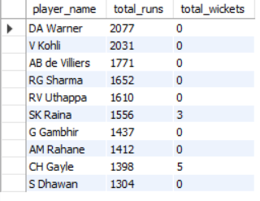
Visualization (Wherever required) –
Approach-
The analysis compares players based on their historical total runs and wickets to identify players who could be strong additions to RCB. The top 10 players by total runs were visualized to make the leading performers easier to compare, while wickets were also considered to identify players who provide an additional contribution with the ball.
Insight -
- DA Warner (2,077 runs) and V Kohli (2,031 runs) are the two highest run-scorers in the analysis.
- AB de Villiers (1,771 runs) and RG Sharma (1,652 runs) also show strong and consistent batting output.
- RV Uthappa (1,610 runs) and SK Raina (1,556 runs) are also among the leading performers.
- Among the top 10, SK Raina (3 wickets) and CH Gayle (5 wickets) also have bowling contributions, giving them some additional versatility.
Recommendation -
RCB should prioritize proven high-performing players such as DA Warner, V Kohli, AB de Villiers and RG Sharma when considering batting strength. Players such as SK Raina and CH Gayle can also be considered where additional all-round contribution is valuable.
3 - What are some of the parameters that should be focused on while selecting the players?
Code -
select p.player_name,
coalesce(b.total_runs, 0) as total_runs,
coalesce(w.total_wickets, 0) as total_wickets,
timestampdiff(year, p.dob, curdate()) as age, bs.batting_hand,
bw.bowling_skill, r.role_desc
from player as p
left join
(select striker as player_id, sum(runs_scored) as total_runs
from ball_by_ball
group by striker
) as b on p.player_id = b.player_id
left join
(select bb.bowler as player_id, count(*) as total_wickets
from ball_by_ball as bb
join wicket_taken as wt
on bb.match_id = wt.match_id
and bb.over_id = wt.over_id
and bb.ball_id = wt.ball_id
and bb.innings_no = wt.innings_no
where wt.kind_out in (1, 2, 4, 6, 7, 8)
group by bb.bowler
)as w on p.player_id = w.player_id
left join batting_style as bs
on p.batting_hand = bs.batting_id
left join bowling_style as bw
on p.bowling_skill = bw.bowling_id
left join
(select player_id, min(role_id) as role_id
from player_match
group by player_id) as
pm on p.player_id = pm.player_id
left join rolee as r
on pm.role_id = r.role_id
where coalesce(b.total_runs, 0) > 0
or coalesce(w.total_wickets, 0) > 0
order by total_runs desc, total_wickets desc
limit 15;
Output image of SQL -
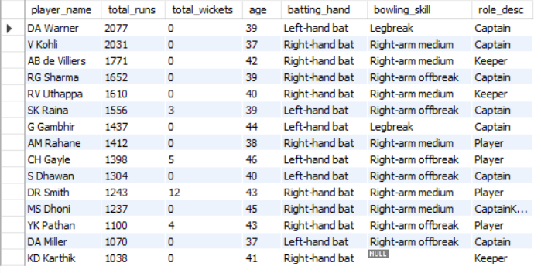
Visualization (Wherever required) – NA
Approach-
The analysis considers multiple parameters instead of selecting players based only on total runs. Player performance, bowling contribution, age, batting hand, bowling skill, and playing role are examined to understand both the player's current contribution and how well the player can fit into the team's overall requirements.
Insight -
The results show that player selection should consider both performance and squad balance. For example, DA Warner and V Kohli have very high run totals, while DR Smith has 12 wickets and YK Pathan has 4 wickets, showing that some players can provide additional bowling contribution. The data also shows different batting hands, bowling skills, ages, and roles, which are important for building a balanced squad.
Recommendation -
RCB should focus on these key parameters while selecting players:
- Batting performance – total runs.
- Bowling performance – total wickets.
- Age – for balancing immediate performance with long-term squad planning.
- Batting hand – to maintain left/right-hand batting combinations.
- Bowling skill – to ensure variety in the bowling attack.
- Player role – to maintain the required balance between batters, bowlers, keepers and all-rounders.
4 - Which players offer versatility in their skills and can contribute
effectively with both bat and ball? (can you visualize the data for the same).
Code -
with batting as (select
striker as player_id,
sum(runs_scored) as total_runs
from ball_by_ball
group by striker), bowling as (
select bb.bowler as player_id,
count(*) as total_wickets
from ball_by_ball as bb
join wicket_taken as wt
on bb.match_id = wt.match_id
and bb.over_id = wt.over_id
and bb.ball_id = wt.ball_id
and bb.innings_no = wt.innings_no
where wt.kind_out in (1, 2, 4, 6, 7, 8)
group by bb.bowler),
ranked as (select p.player_name,
b.total_runs, w.total_wickets,
rank() over(order by b.total_runs desc) as batting_rank,
rank() over(order by w.total_wickets desc) as bowling_rank
from player as p
join batting as b
on p.player_id = b.player_id
join bowling as w
on p.player_id = w.player_id)
select player_name,
total_runs, total_wickets,
batting_rank, bowling_rank,
batting_rank + bowling_rank as versatility_score
from ranked
order by versatility_score
limit 10;
Output image of SQL –
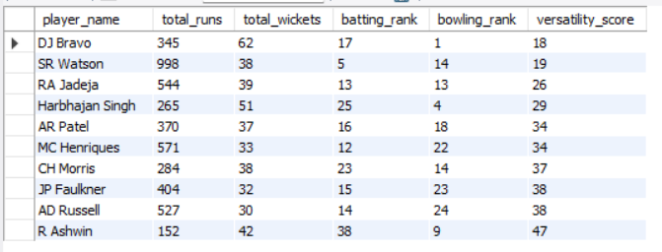
Visualization (Wherever required) –
Approach-
Players were ranked separately on their batting performance and bowling performance. The two ranks were combined into a versatility score, where a lower score indicates stronger performance across both departments. The top 10 players were then visualized using runs and wickets to compare their overall versatility.
Insight -
The analysis identifies DJ Bravo, SR Watson, RA Jadeja, Harbhajan Singh and AR Patel among the strongest two-way contributors.
- DJ Bravo has the highest bowling contribution with 62 wickets.
- SR Watson provides the strongest batting contribution among these players with 998 runs, along with 38 wickets.
- RA Jadeja contributes 544 runs and 39 wickets, showing a strong balance between both departments.
- Harbhajan Singh has 51 wickets, while AR Patel contributes 370 runs and 37 wickets.
The results demonstrate that these players can provide RCB with additional flexibility because they contribute in both batting and bowling.

Recommendation -
RCB should consider multi-skilled players such as SR Watson, RA Jadeja, DJ Bravo and AR Patel when building a balanced squad. Such players can provide additional batting or bowling options and reduce dependence on specialists, giving the team greater tactical flexibility.
5 - Are there players whose presence positively influences the morale
and performance of the team? (justify your answer using visualization).

Code -
with rcb_matches as (
select match_id, match_winner
from matches where team_1 = 2 or team_2 = 2
), player_performance as (
select p.player_id, p.player_name,
count(distinct pm.match_id) as matches_with_player,
sum(case when m.match_winner = 2 then 1 else 0 end) as wins_with_player
from player as p
join player_match as pm
on p.player_id = pm.player_id
and pm.team_id = 2
join rcb_matches as m
on pm.match_id = m.match_id
group by p.player_id, p.player_name),
rcb_summary as (select
count(*) as total_matches,
sum(case when match_winner = 2 then 1 else 0 end) as total_wins
from rcb_matches ) select
pp.player_name, pp.matches_with_player,
pp.wins_with_player,
round(
pp.wins_with_player * 100.0 / pp.matches_with_player, 2
) as win_percentage_with_player,
rs.total_matches - pp.matches_with_player as matches_without_player,
rs.total_wins - pp.wins_with_player as wins_without_player,
round(
(rs.total_wins - pp.wins_with_player) * 100.0 /
nullif(rs.total_matches - pp.matches_with_player, 0), 2
) as win_percentage_without_player, round(
(pp.wins_with_player * 100.0 / pp.matches_with_player)
-
((rs.total_wins - pp.wins_with_player) * 100.0 /
nullif(rs.total_matches - pp.matches_with_player, 0)), 2
) as win_percentage_difference
from player_performance as pp
cross join rcb_summary as rs
where pp.matches_with_player >= 10
order by win_percentage_difference desc
limit 10;
Output image of SQL -
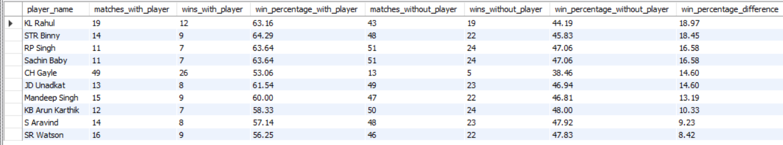
Visualization (Wherever required) –
Approach-
Since morale cannot be directly measured from the available IPL data, team performance is used as a measurable proxy. RCB's win percentage when a player participated is compared with the win percentage when the player was absent. A consistently higher win percentage with the player indicates a positive association with team performance.
Insight -
The analysis shows a clear positive difference for all the players displayed.
- KL Rahul has the highest difference: 18.97 percentage points — RCB won 63.16% of matches with him compared with 44.19% without him.
- STR Binny shows an 18.45-point difference.
- RP Singh and Sachin Baby both show a 16.58-point difference.
- CH Gayle and JD Unadkat each show a 14.60-point difference.
- Even SR Watson, the lowest among the displayed players, has a positive 8.42-point difference.
The chart clearly shows that RCB's win percentage is higher when each of these players is present.

Recommendation -
RCB should consider retaining or targeting players who consistently show a positive association with team results, especially KL Rahul, STR Binny, RP Singh and Sachin Baby based on this analysis. However, this should be treated as a performance association rather than proof that the players directly caused better morale or wins, and should be combined with individual performance and role requirements before making final squad decisions.
6 - What would you suggest to RCB before going to the mega auction?
Code –
with batting as (
select striker as player_id,
sum(runs_scored) as total_runs
from ball_by_ball
group by striker), bowling as
(select bb.bowler as player_id,
count(*) as total_wickets
from ball_by_ball as bb
join wicket_taken as wt
on bb.match_id = wt.match_id
and bb.over_id = wt.over_id
and bb.ball_id = wt.ball_id
and bb.innings_no = wt.innings_no
where wt.kind_out in (1, 2, 4, 6, 7, 8)
group by bb.bowler)
select p.player_name,
coalesce(b.total_runs, 0) as total_runs,
coalesce(w.total_wickets, 0) as total_wickets,
r.role_desc
from player as p
join player_match as pm
on p.player_id = pm.player_id
and pm.team_id = 2
left join batting as b
on p.player_id = b.player_id
left join bowling as w
on p.player_id = w.player_id
left join rolee as r
on pm.role_id = r.role_id
group by p.player_id, p.player_name,
b.total_runs, w.total_wickets, r.role_desc
order by total_runs desc, total_wickets desc
limit 15;

Output image of SQL -
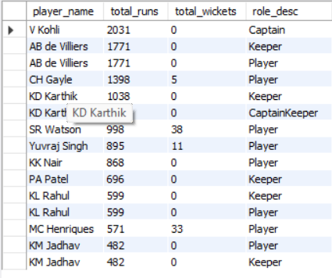
Visualization (Wherever required) –
Approach-
The analysis evaluates players based on their historical batting contribution, bowling contribution and playing roles to identify the strengths and gaps that RCB should consider before the mega auction.
Insight -
The results show that RCB has strong batting contributors such as V Kohli, AB de Villiers and CH Gayle. At the same time, players such as SR Watson and MC Henriques provide contributions in both batting and bowling. This indicates that RCB should not focus only on high-scoring batters and should also consider players who provide value in multiple areas.
Recommendation -
RCB should prioritize retaining proven performers, adding quality all-rounders and strengthening the bowling department. The team should maintain a balanced squad across batting, bowling, wicketkeeping and all-round roles instead of concentrating most of the auction budget on specialist batters.
7 - What do you think could be the factors contributing to the high-scoring matches and the impact on viewership and team strategies.
Code -
select m.match_id, v.venue_name,
m.toss_decide, m.match_winner,
sum(bb.runs_scored + coalesce(er.extra_runs, 0)) as total_match_runs
from matches as m
join ball_by_ball as bb
on m.match_id = bb.match_id
left join extra_runs er
on bb.match_id = er.match_id
and bb.over_id = er.over_id
and bb.ball_id = er.ball_id
and bb.innings_no = er.innings_no
join venue as v
on m.venue_id = v.venue_id
where m.team_1 = 2
or m.team_2 = 2
group by m.match_id, v.venue_name,
m.toss_decide, m.match_winner
order by total_match_runs desc
limit 15;
Output image of SQL -
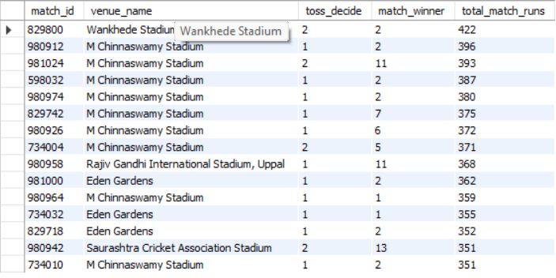
Visualization (Wherever required) –
The chart shows that the highest-scoring match in the analysis had 422 runs, followed by matches with 396, 393, 387 and 380 runs.
Approach-
The analysis identifies RCB's highest-scoring matches and examines their venue and toss decision to understand possible factors associated with high-scoring games. These factors can then be connected to batting-friendly conditions and the strategic choices made by teams.
Insight -
The results show that M Chinnaswamy Stadium appears frequently among RCB's high-scoring matches, indicating that the venue's conditions may support high-scoring games. Wankhede Stadium and Eden Gardens also appear among the high-scoring matches.
The toss decisions are mixed, but field-first appears more frequently among the top high-scoring matches in the displayed results. This suggests that teams may prefer chasing in conditions where scoring remains favorable.
High-scoring matches can also create greater viewer interest and entertainment value, although the current dataset does not contain viewership figures, so we cannot directly measure the increase in viewership.

Recommendation -
RCB should use venue-specific scoring patterns when planning its strategy. At high-scoring venues such as M Chinnaswamy Stadium, RCB should prioritize strong batting depth, aggressive powerplay batting and sufficient bowling options to handle high run rates. Toss decisions should also be evaluated according to the venue and match conditions rather than following a fixed strategy.
8 - Analyze the impact of home-ground advantage on team performance and identify strategies to maximize this advantage for RCB.
Code -
select case
when v.venue_name = 'M Chinnaswamy Stadium' then 'home'
else 'away' end as match_location,
count(*) as total_matches,
sum(case when m.match_winner = 2 then 1 else 0 end) as matches_won,
sum(case when m.match_winner <> 2 then 1 else 0 end) as matches_lost,
round(
sum(case when m.match_winner = 2 then 1 else 0 end) * 100.0 / count(*),
2) as win_percentage
from matches as m
join venue as v on m.venue_id = v.venue_id
where m.team_1 = 2
or m.team_2 = 2
group by case
when v.venue_name = 'M Chinnaswamy Stadium'
then 'home' else 'away' end;
Output image of SQL -
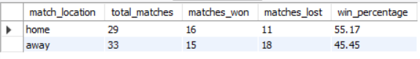
Visualization (Wherever required) –
Approach-
RCB's performance at its home ground, M Chinnaswamy Stadium, is compared with its performance at away venues using total matches, wins, losses and win percentage. This helps determine whether playing at home provides a measurable performance advantage.
Insight -
RCB has a 55.17% win percentage at home, compared with 45.45% away from home.
- Home: 29 matches, 16 wins, 11 losses
- Away: 33 matches, 15 wins, 18 losses
- Home advantage = approximately 9.72 percentage points
The results indicate that RCB performs better at home. The higher home win percentage suggests that familiarity with the conditions and venue can provide RCB with a meaningful advantage.

Recommendation -
RCB should maximize this advantage by:
- Building the playing XI according to Chinnaswamy's conditions.
- Maintaining strong batting depth, particularly because the venue can support high scoring.
- Preparing bowlers specifically for the venue's conditions and shorter boundaries.
- Using venue-specific toss and chasing strategies.
- Practicing regularly at the home venue to improve familiarity with pitch and boundary dimensions.
- Using the stronger home record to maximize points from home fixtures, while simultaneously improving away performance.
Key conclusion: RCB's home win rate is almost 10 percentage points higher than its away win rate, so home-ground advantage is clearly visible in this dataset.
9 - Come up with a visual and analytical analysis of the RCB's past season's performance and potential reasons for them not winning a trophy.
Code -
with rcb_matches as (select
match_id, season_id, match_winner
from matches where team_1 = 2
or team_2 = 2),
match_stats as (select season_id,
count(*) as total_matches,
sum(case when match_winner = 2 then 1 else 0 end) as matches_won,
sum(case when match_winner <> 2 then 1 else 0 end) as matches_lost
from rcb_matches group by season_id),
run_stats as (select rm.season_id,
sum(bb.runs_scored) as total_runs
from rcb_matches as rm
join ball_by_ball as bb
on rm.match_id = bb.match_id
group by rm.season_id)
select s.season_year, ms.total_matches,
ms.matches_won, ms.matches_lost,
round(ms.matches_won * 100.0 / ms.total_matches, 2) as
win_percentage, rs.total_runs,
round(rs.total_runs * 1.0 / ms.total_matches, 2) as avg_runs_per_match
from match_stats as ms
join run_stats as rs
on ms.season_id = rs.season_id
join season as s
on ms.season_id = s.season_id
order by s.season_year;
Output image of SQL -
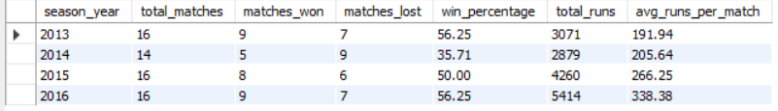
Visualization (Wherever required) –
Approach-
The analysis compares RCB's season-wise matches won and lost along with win percentage, total runs and average runs per match. This helps identify consistency in performance and possible areas that prevented RCB from achieving sustained success.
Insight -
2013: 9 wins, 7 losses — 56.25% win rate
- 2014: 5 wins, 9 losses — 35.71% win rate
- 2015: 8 wins, 6 losses — 50.00% win rate
- 2016: 9 wins, 7 losses — 56.25% win rate
RCB's performance was not consistently dominant across seasons. The biggest weakness was 2014, when RCB won only 5 of 14 matches and had a 35.71% win percentage.
Interestingly, RCB's scoring improved substantially:
- 2013: 3,071 runs
- 2014: 2,879 runs
- 2015: 4,260 runs
- 2016: 5,414 runs
Despite the strong improvement in scoring, the 2016 win percentage was only 56.25%, suggesting that high run-scoring alone was not enough to guarantee consistent match victories.

Recommendation -
RCB should focus on converting strong batting performances into wins by maintaining balance between batting and bowling. The team should strengthen its bowling attack, improve consistency across seasons, and develop strategies for close or high-scoring matches. The data suggests that improving overall team balance rather than relying primarily on batting strength would be important for sustained tournament success.
10 - How would you approach this problem, if the objective and subjective questions weren't given?

Code – NA
Output image of SQL - NA
Visualization (Wherever required) – NA
Approach-
If the objective and subjective questions were not provided, I would approach the RCB project as a business-driven exploratory data analysis:
- Understand the objective — identify what RCB wants to improve, such as match performance, player selection, team composition and auction strategy.
- Understand the data — examine all available tables, columns, relationships, data types and missing values.
- Clean and validate the data — identify incorrect spellings, duplicates, missing values and inconsistent records.
- Analyze team performance — study season-wise wins/losses, win percentage, runs, wickets and toss outcomes.
- Analyze player performance — compare batting, bowling, consistency and versatility to identify valuable players.
- Analyze match and venue factors — study home vs away performance, venues, toss decisions and high-scoring matches.
- Identify patterns and problems — determine what factors are associated with wins, losses and inconsistent performance.
- Create visualizations — use suitable charts such as bar charts, scatter plots and comparisons to communicate the findings clearly.
- Generate recommendations — convert the findings into actionable suggestions for player selection, team strategy and the mega auction.

Insight -
Without predefined questions, the analysis would be exploratory rather than question-driven. I would first investigate the major performance areas and then formulate meaningful business questions from the patterns found in the data.
Recommendation -
RCB should use this approach to build a data-driven decision framework rather than analyzing isolated statistics. The final objective would be to identify what is working, what is not working, why it is happening, and what RCB should change to improve future performance.

11 - In the "Match" table, some entries in the "Opponent_Team" column are incorrectly spelled as "Delhi_Capitals" instead of "Delhi_Daredevils". Write an SQL query to replace all occurrences of "Delhi_Capitals" with "Delhi_Daredevils".

Code - NA
Output image of SQL - NA
Visualization (Wherever required) – NA
Approach-
The question refers to an Opponent_Team column containing Delhi_Capitals, but our database has no Opponent_Team column and the team table also does not contain Delhi_Capitals. Therefore, there is no matching record that can be updated.
Insight -
In our database, teams are represented through team IDs in the matches table and their names are maintained separately in the team table. Since Delhi_Capitals does not exist in either relevant location, the stated correction cannot be performed on the provided dataset.
Recommendation -
Do not run an UPDATE query just to satisfy the question, because it could modify the wrong data. Mention that the question appears to be based on a different version/schema of the dataset.

